# Recipe App Debugging and Function Testing – Kyana Bowers

## Selecting a recipe

Selecting a recipe in the list populates the fields.

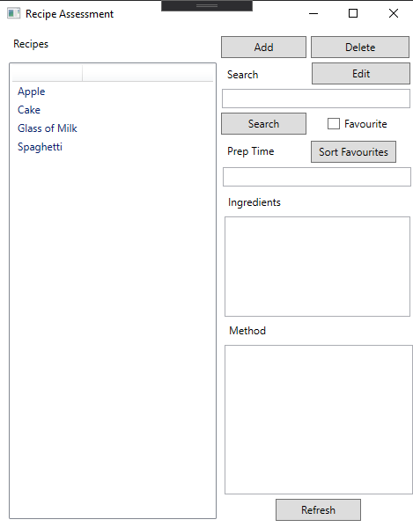

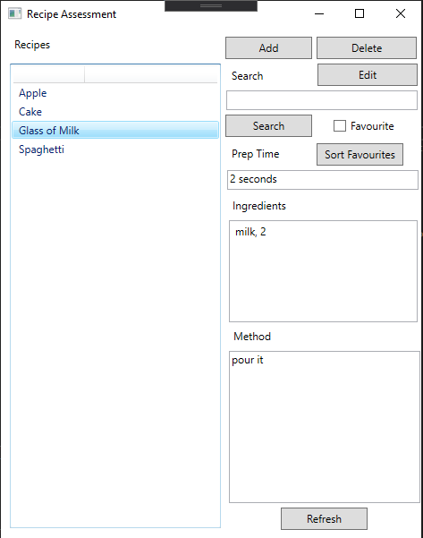

## Searching a recipe

Recipes can be searched by entering the full or part of the recipe name or prep time in the text box.

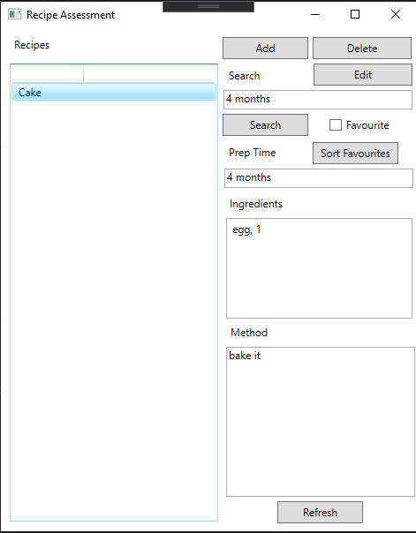

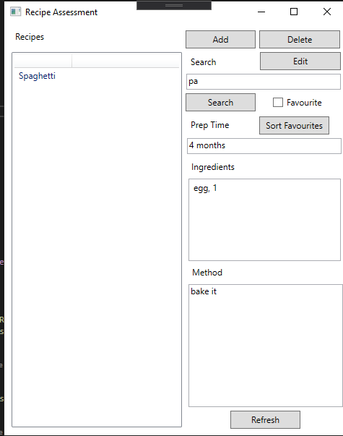

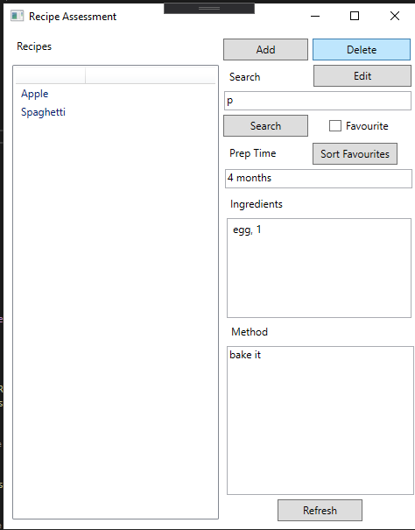

## Editing an existing recipe

Recipes are edited by selecting one from the list and pressing the Edit button. Fields can then be changed and Submitted.

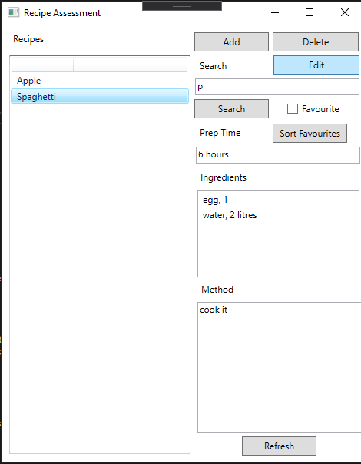

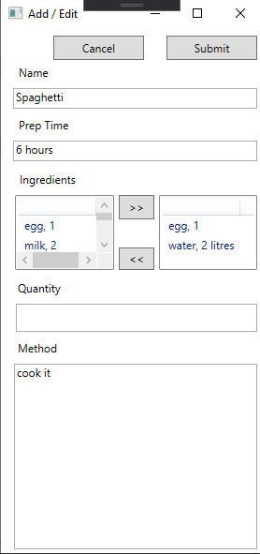

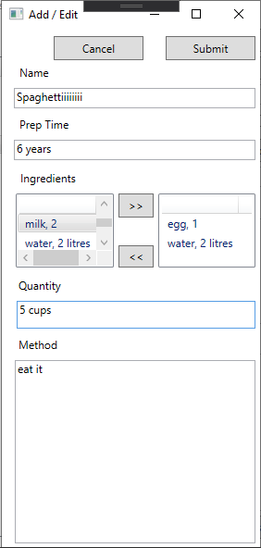

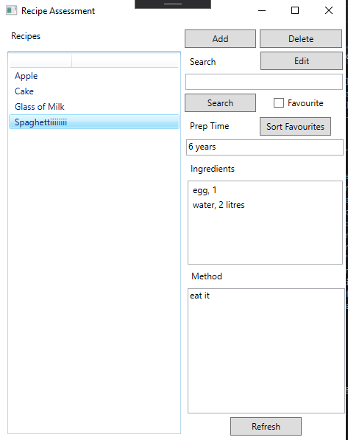

## Deleted recipe

Recipes are deleted by selecting the recipe and pressing the delete button.

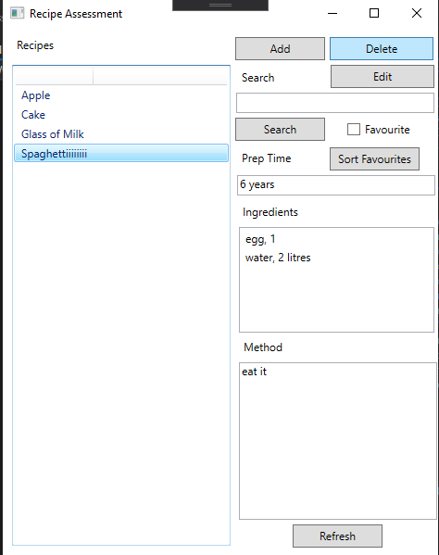

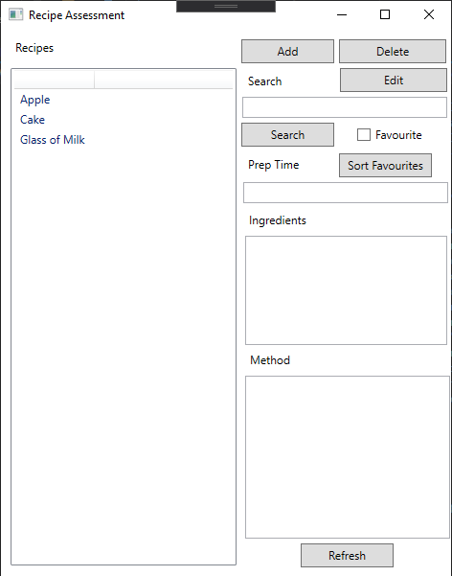

## Adding a new recipe

Recipes are added by pressing the Add button. Fields are entered into the text boxes and ingredients are added using the buttons.

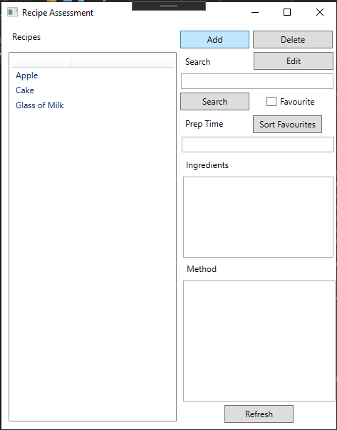

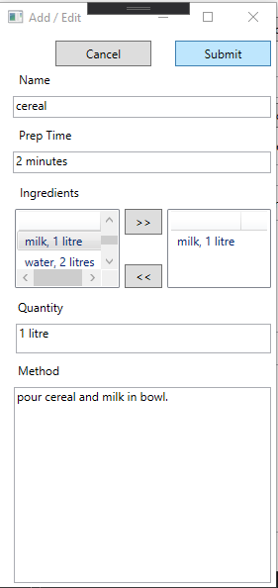

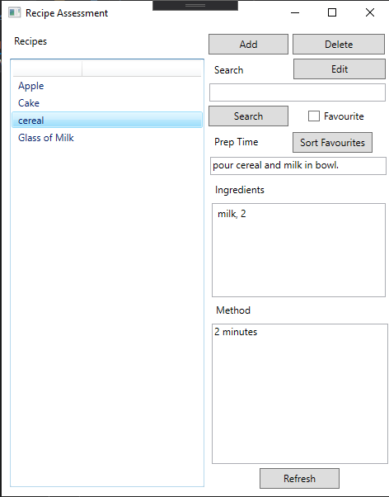

## Favourite button

Favourites are added to a binary file and can be sorted by favourites.

